- ATT Internal Interfaces
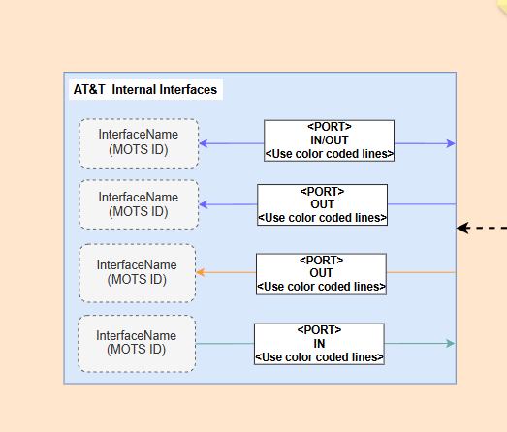
Refer to column G in Interface sheet. Whatever is mentioned as Midrange / Hybrid / Private / Conexus / OnPrem will be listed in this section for Inbound connectivity group by Column N and Column R.
Use the arrow color coding based on below Group by Column N and R.
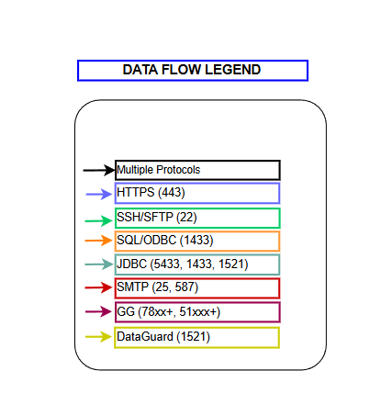
- This section is standard across all application.
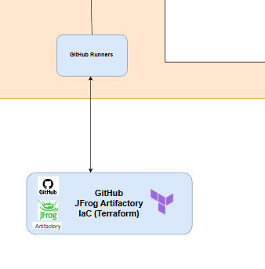
- For AWS Tier 1 Box refer to Interface sheet
Refer to column G in Interface sheet. Whatever is mentioned AWS will be listed in this section for Inbound connectivity group by Column N and Column R.
Use the arrow color coding based on below Group by Column N and R.

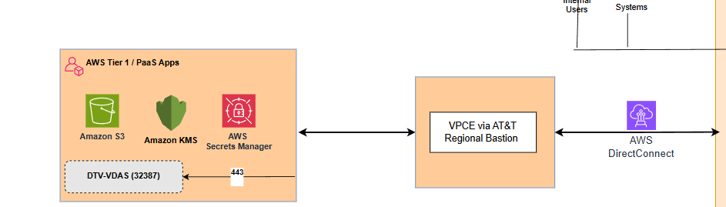
Use the arrow color coding based on below Group by Column N and R.

- This Box will be standard across all Topology Diagrams
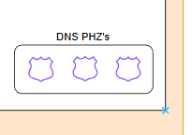

- The data for the below Box should be picked up from App
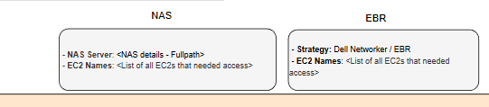
- This Box will be standard across all Topology Diagrams
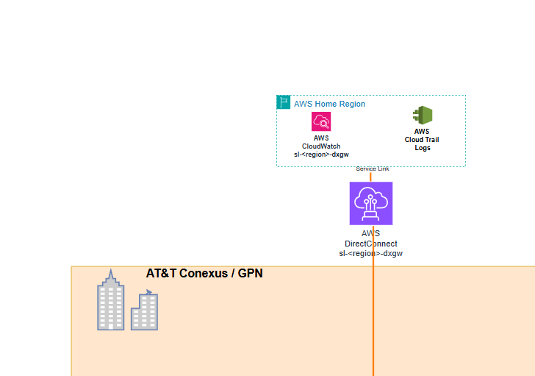

- This Box will be standard across all Topology Diagrams
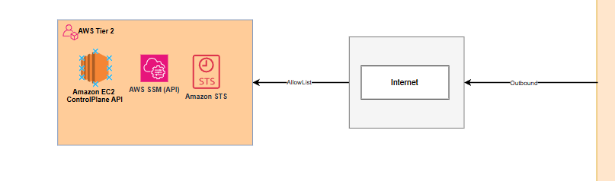
- For Azure – refer to Interface sheet
Refer to column G in Interface sheet. Whatever is mentioned Azure will be listed in this section for Inbound connectivity group by Column N and Column R.
Use the arrow color coding based on below Group by Column N and R.

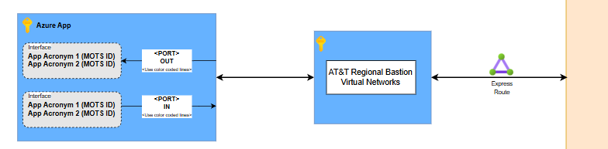

Use the arrow color coding based on below Group by Column N and R.

- This box will be standard across Topology diagrams.
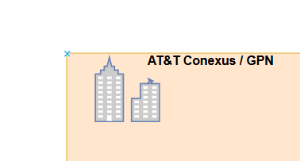

- This box will be standard across Topology diagrams.

